**Assessment Questionnaire**

**For**

**Azure Implementation**

**@ Cloud Nine**

***{6th Sep 2015}***



**Ricoh India Private Limited,**

2nd Floor, Salcon Aurum building,

Plot No. 4, District Centre, Jasola,

New Delhi-110025  
[**www.ricoh.co.in**](http://www.ricoh.co.in)

**Contents**

Document Control 2

Current environment 2

Network 2

Active Directory 3

App Server 3

Database Server 5

Why Azure? 6

About RICOH 8

Ricoh ITS Business & Services Portfolio 8

Ricoh Microsoft Business Unit 9

Why Ricoh for Microsoft Solution ? 10

Ricoh’s Strengths in Cloud & Data-Center solution 10

RID Microsoft Business Approach (differentiator) 10

Ricoh Key Executives related to this business engagement 11

## Document Control

|  |  |
| --- | --- |
| **Document Version** | **Date** |
| Azure Assessment Questionnaire Proposal |  |

## Current environment

### Network

|  |  |  |
| --- | --- | --- |
| **Ref.** | **Question** | **Answer** |
|  | What is the overall topology of your network?  *Please provide an appropriate diagram.* |  |
|  | Can you provide The Network Segmentation Like Server LAN,DMZ Details |  |
|  | What is the current Domain Name System (DNS) infrastructure? Do you have a split DNS? | Please specify the name of DNS Zone exist. |

### Active Directory

|  |  |  |
| --- | --- | --- |
| Ref. | Question | Answer |
|  | How many Active Directory services Forests and Domains do you have in production?  *Provide a diagram if possible.* | If there is multiple domain in same forest please specify the name. |
|  | Please specify the OS version for Active directory and its geographic distribution. |  |

### App Server

|  |  |  |
| --- | --- | --- |
| Ref. | Question | Answer |
|  | Specify the No of Windows 2008/2012 servers. | Server Configuration (Please provide details of server configuration) |
|  | Please specify no of Linux /Unix server. |  |
|  | Does the applications servers hosted on Virtualization Infra, if yes is it VMWARE or Hyper-V? |  |
|  | Does your application using web server like IIS, tomcat , Apache? | Please spacift the no of web server and also  What version of .Net does the application currently use? |
|  | Does application using the NLB or other load balancing features/hardware? |  |
|  | Please provide the current architecture artefacts of the application (these would need to include the software view and physical view). | Please include details of layering, and how communication with the database occurs. |
|  | Does your application is using the Active directory for authentication? Does the user require any users to be authenticated? If so, where are user credentials stored, and where is this store located relative to the application? |  |
|  | Does your application using mail servers for sending mails? |  |
|  | Does the current application use AJAX? If so, does it use 3rd party AJAX libraries, or does it use ASP.Net AJAX? |  |
|  | Does the current application use Silverlight? If yes, which version? |  |
|  | Does the current application use any specific framework (like CSLA.Net, etc.)? |  |
|  | Does the application interface with any other applications? If so, please list the following:  - What is the technology stack and interface mechanism of this other application  - Where is the other application located relative to this application?  - What is the interface type - batch / real-time?  - What is the frequency of this interface being called? |  |
|  | Are there integrations with external systems like payment gateways, etc.? If so, is there a dependency of these external systems on the host name or IP address of this application? |  |
|  | Is there any usage of linked servers? |  |
|  | If encryption is used in the application, where are the keys stored? |  |

### Database Server

|  |  |  |
| --- | --- | --- |
| Ref. | Question | Answer |
|  | Which Database is being used by application? | Server Configuration (Please provide details of server configuration) with DB version? |
|  | What is the current DB size and what are the prospect of future growth? |  |
|  | Does the database have storage of any huge files (audio/video)? |  |
|  | Are there any scheduled jobs that the application uses? | Please specify the no of web server and also  What version of .Net does the application currently use? |
|  | What models of data security that are supported? (Database level, table level, view based, symmetric key encryption, asymmetric key encryption, or combination of symmetric and asymmetric key) |  |

### Why Azure?

Azure is an open and flexible cloud platform that enables you to quickly build, deploy and manage applications across a global network of Microsoft-managed datacenters. You can build applications using any language, tool or framework. And you can integrate your public cloud applications with your existing IT environment.

**99.95% Monthly SLA** - Build and run highly available applications without focusing on infrastructure.

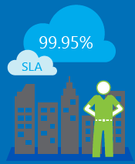

**Automated self-service platform** - Scale applications to any size automatically and provision resources in minutes.



**Open protocols, licensing & tools** - Use whatever language, framework and tools you prefer.

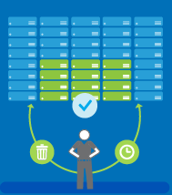

**True Hybrid cloud sans complex workarounds**

Easily move workloads between **your on-prem infra. & Azure**. Unlike AWS’s cloud-only approach, Azure gives you lots of options for an effective **hybrid cloud strategy**, without forcing you to snap to a rigid all-or-nothing approach.

**Enterprise-grade Storage** solutions for on-prem., cloud & hybrid environments, with **enhanced security** **and governance**. Azures provides options for integration with your datacenter. With **VM Portability**, BRIDGE SGI can easily **move VMs “as-is”** across BRIDGE SGI on-premises infra., & Microsoft Azure. With Azure and ExpressRoute BRIDGE SGI would get a fast and reliable connection to Azure making it suitable for scenarios like periodic data migration, replication for business continuity, disaster recovery and other high availability strategies. It can also be a cost-effective option for transferring large amounts of data such as datasets for high performance computing applications or moving large VMs between your dev/test environment in Azure and on-premises production environment.

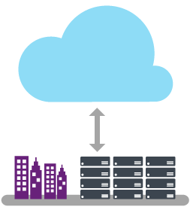**Extend your datacenter**

Azure & ExpressRoute would allow BRIDGE SGI to securely add compute and storage capacity to its existing datacenter. With high throughput and fast latencies, Azure will feel like a natural extension to the BRIDGE SGI’s datacenter, hence enjoying the scale and economics of the public cloud without having to compromise on network performance.

Full advantage of **elasticity & lower costs** in cloud while leveraging on-premises & Azure.

**Identity platform & Security & Privacy**

**Azure AD** provides a comprehensive Identity & Access Management cloud solution to help control access to thousands of Microsoft and non-Microsoft applications in the public cloud. Microsoft leads the industry in its commitment to safeguard Privacy of customer data in the cloud. Microsoft is the first & only cloud provider to receive joint approval to comply with rigorous EU privacy laws. Microsoft boasts of highest no. of security & compliance certifications.



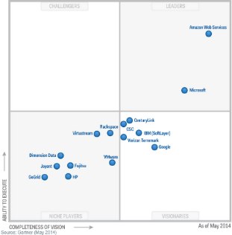**Industry leader for both IaaS & PaaS -** Microsoft is positioned as a Leader in **Gartner’s Magic Quadrants** for Cloud Infrastructure as a Service, x86 Server Virtualization, Enterprise Application Platform as a Service and Public Cloud Storage Services. Only Microsoft has achieved recognition as a Leader across all four capability areas.

## About RICOH

The Ricoh Group has sales and support, production, and research and development operations in around 200 countries under regional headquarters in USA, U.K, Singapore, and Japan.

**Ricoh Founding Principles - The Spirit of Three Loves**

*Love your neighbour, Love your country, Love your work*

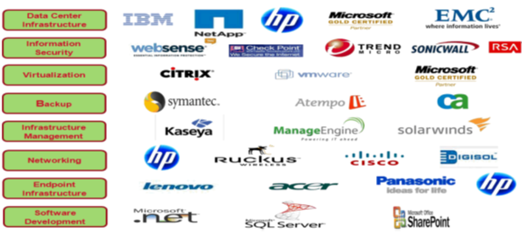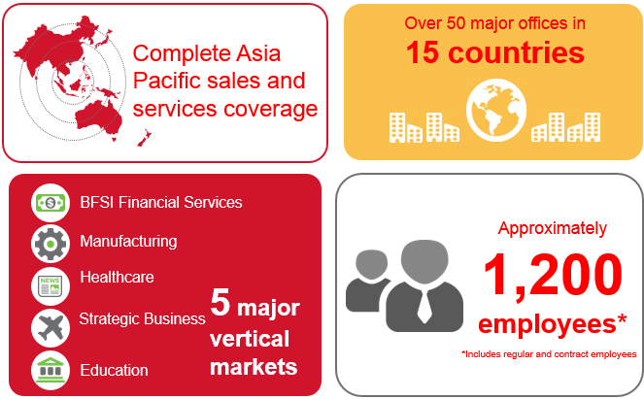**Kiyoshi Ichimura,** Founder － Ricoh Founding Principles

**Ricoh India Alliances**

**Ricoh Presence & Reach**

### Ricoh ITS Business & Services Portfolio

Ricoh India is an ISO 9001-2008 & 14001 Certified, CMMi 3 level certified organization

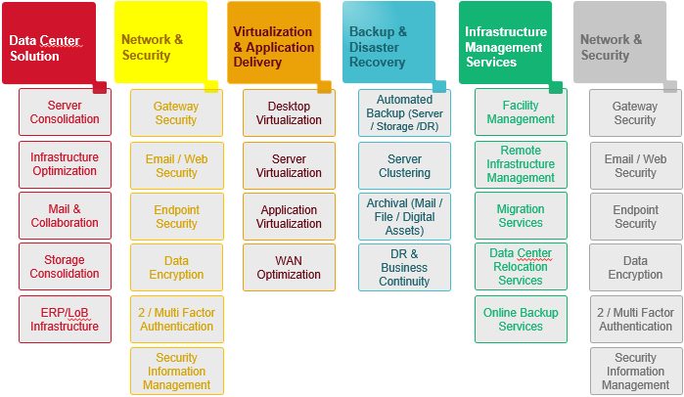

### Ricoh Microsoft Business Unit

Ricoh India Limited is one of the few **Licensing Solutions Providers (LSP)** and **Gold Certified Partner** for Microsoft India and awarded as **best Value Added Reseller** for North & East India by Microsoft for 2014. Ricoh India is **Cloud Deployment Partner**, **Accelerated Partner** (now with **Gold Competency** on Microsoft Cloud Productivity). As a Gold Certified Partner, we have demonstrated expertise with Microsoft technologies and proven ability to meet the needs of our customers. Ricoh India has deployed Microsoft cloud solution across India and Microsoft has published one case study on their portal for the same. Berger Paints, Ilantus, VIOM Networks, Macmillan Publisher, Interglobe Technologies, Methdodex Systems Limited, DIC, ICFAI, CTE, are a few of our Microsoft cloud customers.

### Why Ricoh for Microsoft Solution ?

* Fastest Growing Microsoft Licensing Solution Partner



* Awarded the **“Cloud Ke Badshah**” National Champions in Jan 15
* RID is a single source to manage and maintain your software asset lifecycle over the pending years for budgeting and forecasting of costs.
* RID MS BU can provide expert assistance with deployment, management and migration capabilities while helping you access **MS Early Adopters’ Programs**.
* RID would drive **Quarterly Account Management Reviews** wherein the Microsoft BU National Leads would engage BRIDGE SGI IT & Business Leads ensuring effective **MS IT consumptions** of existing investments.
* RID MS BU would drive **Microsoft Tech Days** bi-annually @ BRIDGE SGI to showcase latest technologies and help recommend future IT roadmaps and adoptions, if any.
* Skilled & competent **Microsoft Certified manpower**

### Ricoh’s Strengths in Cloud & Data-Center solution

* We have own commercially used **Data Centers at Delhi** and **Kolkata**-Running Cloud & hosting services
* We help organizations adopt to **Cloud Technologies across SAAS, PAAS, & IAAS**
* Dedicated Team for On-site and Remote Infrastructure management offering remote technical services to more than 300 customers.( Government & corporate)
* Internal Backup support team for complicated issues.
* **Strong Microsoft BU** with focused resources on Solution Sales, Pre-sales, and services delivery especially around **Microsoft Cloud (both private and public) solution**



### RID Microsoft Business Approach (differentiator)

**RICOH INDIA EA AGREEMENT LIFECYCLE “RID - 36”**

* RID-36 Lifecycle is a proactive engagement plan that provides unique value actionables to engage with BRIDGE SGI during their life-term of MS Enterprise Agreement. This helps to maximize the benefits and deliverables of their Enterprise Agreement within the span of 3 years (36 months), thus delivering a **high ROI** and **lower TCO**.
* The generic plan below maps out a timeline of Ricoh – BRIDGE SGI engagement in-line with Microsoft EA life cycle. This is subject to actionables customized as per BRIDGE SGI’s business and IT roadmaps and requirements.

Year 1: Engagement Plan

Sign-up

Secure

Upgrade

High ROI, Easy & Cost Effective IT Upgrades, Always Up-dated, Low TCO

Benefits to KENT as a customer

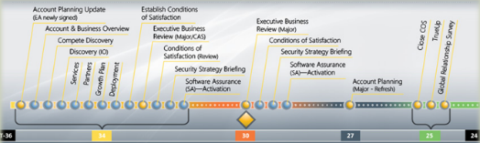

Year 2: Engagement Plan

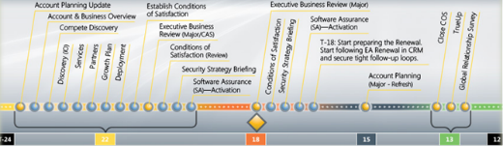

Year 3: Engagement Plan

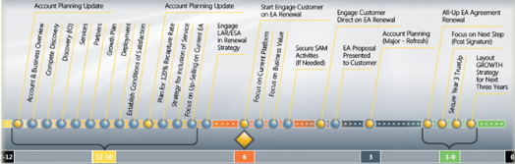

* Realize Value in their Investment in Annuity agreement
* Proactive engagement with RID as a trusted advisor

### Ricoh Key Executives related to this business engagement

|  |  |  |
| --- | --- | --- |
| **Role / Designation** | **Name** | **Email ID** |
| Account Manager – RID MS BU | Rajib | Rajib.majunder@ricoh.co.in |
| Presales Manager- MSBU | Vinod Kammula | Vinod.kammula@ricoh.co.in |
| Pre-Sales Group Leader - MS BU | Amit tyagi | Amit.tyagi@ricoh.co.in |
| Corp. Business Lead – RID MS BU | Anand Rao | [anand.rao@ricoh.co.in](mailto:anand.rao@ricoh.co.in) |
| SMB & EPG Business Lead – RID MS BU | Niti Verma | Nitin.verma@ricoh.co.in |
| National Pre-Sales Head – RID MS BU | Anand Dutta | [anand.dutta@ricoh.co.in](mailto:anand.dutta@ricoh.co.in) |
| National Solution Business Lead – RID MS BU | Sushan Aich | [sushan.aich@ricoh.co.in](mailto:sushan.aich@ricoh.co.in) |

End of document –